
STARS
School Transition & Adjustment Research Study

Stage 2: Starting Secondary School

QUESTIONNAIRE FOR YOUNG PEOPLE

A study about moving to secondary school

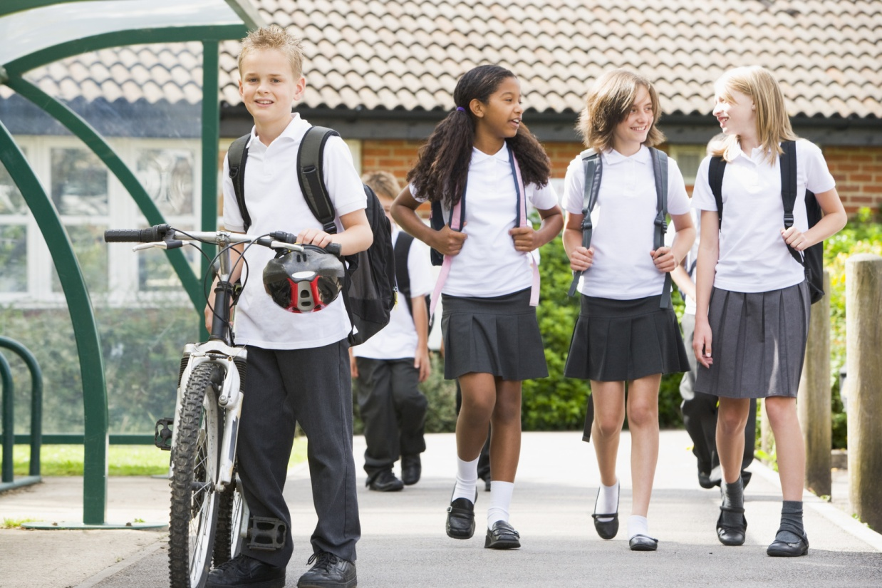

Moving to Your New School
- Please tell us whether your primary school did any of the things listed to help you prepare for secondary school? AND
- Tell us how much you think every item on the list helped/would have helped you to prepare
Did your primary school... | Did your primary school do this? |  |  |  | How helpful?  (please answer for every item)
Did your primary school... | No | Yes, a little |  | Yes, a lot | Not at all | Very Little |  | Some-what |  | Quite a bit | Very much
- Use websites to teach you about secondary school? | 0 | 1 |  | 2 | 0 | 1 |  | 2 |  | 3 | 4
- Put you into groups so that you could work with other children who were going to your secondary school? | 0 | 1 |  | 2 | 0 | 1 |  | 2 |  | 3 | 4
- Start a project with your class which you finished working on when you got to secondary school? | 0 | 1 |  | 2 | 0 | 1 |  | 2 |  | 3 | 4
- Give you a booklet which you could fill out with information about yourself that you could take to secondary school? | 0 | 1 |  | 2 | 0 | 1 |  | 2 |  | 3 | 4
- Give you leaflets and other written information about your secondary school? | 0 | 1 |  | 2 | 0 | 1 |  | 2 |  | 3 | 4
- Organise visits for your whole class to go to your secondary school? | 0 | 1 |  | 2 | 0 | 1 |  | 2 |  | 3 | 4
- Organise visits for just you to go to your secondary school? | 0 | 1 |  | 2 | 0 | 1 |  | 2 |  | 3 | 4
- Change your timetable in year 6 so that it was more like your timetable at secondary school? | 0 | 1 |  | 2 | 0 | 1 |  | 2 |  | 3 | 4
- Give you extra responsibilities in year 6 (e.g. becoming a monitor)? | 0 | 1 |  | 2 | 0 | 1 |  | 2 |  | 3 | 4
 | No | Yes, a little |  | Yes, a lot | Not at all | Very Little |  | Some-what |  | Quite a bit | Very much
- Give assemblies about moving to secondary school? | 0 | 1 |  | 2 | 0 | 1 |  | 2 |  | 3 | 4
- Talk to you and the class about any worries that you had about secondary school? | 0 | 1 |  | 2 | 0 | 1 |  | 2 |  | 3 | 4
Did your primary school do anything else to help you? If yes, please write what they did in the boxes below and say how much you think it helped you prepare for the move to secondary school.
 |  |  | How helpful was this in preparing you for the move to secondary school? (circle answer)
................................................................................................ |  |  | Not at all |  | Very Little |  | Some-what |  | Quite a bit |  | Very much
................................................................................................ |  |  | Not at all |  | Very Little |  | Some-what |  | Quite a bit |  | Very much

Your New School
Here is an example of a rating scale:
1 2 3 4 5 6 7 8 9 10
Not at all worried
I get extremely worried about it

We would like to ask you some questions about any concerns or worries you may have about your new secondary school. Please rate each of the following using the scale above.
For example, if you were really worried you would put a 10 in the box beside it.
Making new friends |  | Older children |  | Lots of different teachers |  | Following a timetable
Being bullied |  | Getting to school |  | Homework |  | Dinner times
PE |  | Changing classes |  | Being able to do the work |  | Toilets
Remembering equipment for school |  | What to do if you are feeling ill |  | Lots of people |  | Break time
Size of school |  | Discipline and detentions |  | Losing old friends |  | Getting lost
If you have any other concerns you can write in the boxes below and then rate your concerns with the same scale as above…
................................................................................ |  |  |  | ................................................................................

Please tick your answer to the following questions: | Not at all | Very little |  | Some-what |  | Quite a bit |  | Very much
- Were you looking forward to going to secondary school? | 1 | 2 |  | 3 |  | 4 |  | 5
- Were you worried about going to secondary school? | 1 | 2 |  | 3 |  | 4 |  | 5
- Did you feel prepared for going to secondary school? | 1 | 2 |  | 3 |  | 4 |  | 5
- Is there anything that you didn’t feel prepared for? | 1 | 2 |  | 3 |  | 4 |  | 5
If yes, what was it? ................................................................................................................................................
If the statement is definitely true, tick ‘1’ for ‘YES!!’. If you think the statement is definitely not true, tick ‘4’ for ‘NO!!’. | YES!! |  | yes |  | no |  | NO!!
- I like my school | 1 |  | 2 |  | 3 |  | 4
- I wish I didn’t have to go to school | 1 |  | 2 |  | 3 |  | 4
- I wish I could go to a different school | 1 |  | 2 |  | 3 |  | 4
- I’m bored in my school | 1 |  | 2 |  | 3 |  | 4
- I am glad to get back to school after the holidays | 1 |  | 2 |  | 3 |  | 4
- I would be very sad if I had to go to a different school | 1 |  | 2 |  | 3 |  | 4
- I hate being in this school | 1 |  | 2 |  | 3 |  | 4
- The teachers here really care about me | 1 |  | 2 |  | 3 |  | 4
- Teachers can’t be trusted; they say one thing at one time and something different the next time | 1 |  | 2 |  | 3 |  | 4
- The teachers here always keep their promises | 1 |  | 2 |  | 3 |  | 4
- The teachers here don’t care what I think | 1 |  | 2 |  | 3 |  | 4
- The teachers here always try to be fair | 1 |  | 2 |  | 3 |  | 4
- Teachers here punish children without even knowing what really happened | 1 |  | 2 |  | 3 |  | 4
- I feel safe and comfortable with the teachers in this school | 1 |  | 2 |  | 3 |  | 4
- Teachers in this school get cross whenever you make a mistake | 1 |  | 2 |  | 3 |  | 4
- When my teacher tells me not to do something I want to do, I know he or she must have a good reason | 1 |  | 2 |  | 3 |  | 4
- Our teacher will always listen to our ideas about how to make the class rules better | 1 |  | 2 |  | 3 |  | 4

Answer about the school that you are currently attending. | Strongly Disagree | Disagree | Not sure | Agree | Strongly Agree
- You feel close to people at school | 1 | 2 | 3 | 4 | 5
- Teachers care about you | 1 | 2 | 3 | 4 | 5
- You feel part of your school | 1 | 2 | 3 | 4 | 5
- You feel happy at school | 1 | 2 | 3 | 4 | 5
- You feel teachers treat students fairly | 1 | 2 | 3 | 4 | 5
- You feel safe in your school | 1 | 2 | 3 | 4 | 5
 | Not true at all | Hardly ever true | Some-times true | True most of the time | Always true
- It is easy for me to make new friends at school | 1 | 2 | 3 | 4 | 5
- I have nobody to talk to in class | 1 | 2 | 3 | 4 | 5
- I feel alone at school | 1 | 2 | 3 | 4 | 5
- I can find a friend in my class when I need one | 1 | 2 | 3 | 4 | 5
- I feel left out of things at school | 1 | 2 | 3 | 4 | 5
- I’m lonely at school | 1 | 2 | 3 | 4 | 5
- I am well liked by the children in my class | 1 | 2 | 3 | 4 | 5

 | Never | Seldom | Some-times | Often | Always
- How often do you try to learn something new even when you don't have to? | 1 | 2 | 3 | 4 | 5
- How often do you try to learn as much as you can about a new subject? | 1 | 2 | 3 | 4 | 5
- How often do you try to work hard to understand what you are studying? | 1 | 2 | 3 | 4 | 5
- How often do you try to find things to learn in class that are new and challenging? | 1 | 2 | 3 | 4 | 5
- How often do you try to show your teachers how clever you are? | 1 | 2 | 3 | 4 | 5
- How often do you try to learn things ONLY because you want to get a good mark? | 1 | 2 | 3 | 4 | 5
- How often do you try to make sure your teachers know you have been working hard? | 1 | 2 | 3 | 4 | 5
- How often do you try to get better marks than other children in your class? | 1 | 2 | 3 | 4 | 5
- How often do you try to show you've learned more than your classmates? | 1 | 2 | 3 | 4 | 5
- How often do you try to get more answers right than your classmates? | 1 | 2 | 3 | 4 | 5

Family
Not all families are the same, so some of the next questions might not apply to you.
A | During the past month when you and your mum (or the person like your mum, e.g. carer, step-mum) have spent time talking or doing things together, how often did your mum...
If you have not been in touch with them in the last month please tick here and go on to ‘B’.
 |  |  | Always | Almost Always | Fairly Often | About Half | Not too Often | Almost Never | Never
- Get angry at you |  |  | 1 | 2 | 3 | 4 | 5 | 6 | 7
- Let you know she really cares about you |  |  | 1 | 2 | 3 | 4 | 5 | 6 | 7
- Criticise you or your ideas |  |  | 1 | 2 | 3 | 4 | 5 | 6 | 7
- Shout at you because she was upset with you |  |  | 1 | 2 | 3 | 4 | 5 | 6 | 7
- Act loving and affectionate toward you |  |  | 1 | 2 | 3 | 4 | 5 | 6 | 7
- Let you know that she appreciates you, your ideas or the things you do |  |  | 1 | 2 | 3 | 4 | 5 | 6 | 7
- Help you do something that was important to you |  |  | 1 | 2 | 3 | 4 | 5 | 6 | 7
- Argue with you when you disagreed about something |  |  | 1 | 2 | 3 | 4 | 5 | 6 | 7
- Act supportive and understanding toward you |  |  | 1 | 2 | 3 | 4 | 5 | 6 | 7
- Tell you she loves you |  |  | 1 | 2 | 3 | 4 | 5 | 6 | 7
B |  | During the past month when you and your dad (or the person like your dad, e.g. carer, step-dad) have spent time talking or doing things together, how often did your dad...
If you have not been in touch with them in the last month please tick here and go on to the next section
‘Your Feelings’.
 |  |  | Always | Almost Always | Fairly Often | About Half | Not too Often | Almost Never | Never
- Get angry at you |  |  | 1 | 2 | 3 | 4 | 5 | 6 | 7
- Let you know he really cares about you |  |  | 1 | 2 | 3 | 4 | 5 | 6 | 7
- Criticise you or your ideas |  |  | 1 | 2 | 3 | 4 | 5 | 6 | 7
- Shout at you because he was upset with you |  |  | 1 | 2 | 3 | 4 | 5 | 6 | 7
- Act loving and affectionate toward you |  |  | 1 | 2 | 3 | 4 | 5 | 6 | 7
- Let you know that he appreciates you, your ideas or the things you do |  |  | 1 | 2 | 3 | 4 | 5 | 6 | 7
 |  |  | Always | Almost Always | Fairly Often | About Half | Not too Often | Almost Never | Never
- Help you do something that was important to you |  |  | 1 | 2 | 3 | 4 | 5 | 6 | 7
- Argue with you when you disagreed about something |  |  | 1 | 2 | 3 | 4 | 5 | 6 | 7
- Act supportive and understanding toward you |  |  | 1 | 2 | 3 | 4 | 5 | 6 | 7
- Tell you he loves you |  |  | 1 | 2 | 3 | 4 | 5 | 6 | 7

You’re half way there…

For each item, please tick the box for Not True, Sort of True or Certainly True. It would help us if you answered all items as best you can, even if you are not absolutely certain. Please give your answers on the basis of your behaviour over the last 6 months.
 | Not True | Sort of True |  | Certainly True
- I try to be nice to other people, I care about their feelings | 0 | 1 |  | 2
- I am restless, I cannot stay still for long | 0 | 1 |  | 2
- I get a lot of headaches, stomach-aches or sickness | 0 | 1 |  | 2
- I usually share with others (food, games, pens, etc.) | 0 | 1 |  | 2
- I get very angry and often lose my temper | 0 | 1 |  | 2
- I am usually on my own. I generally play alone or keep to myself | 0 | 1 |  | 2
- I usually do as I am told | 0 | 1 |  | 2
- I worry a lot | 0 | 1 |  | 2
- I am helpful if someone is hurt, upset or feeling ill | 0 | 1 |  | 2
- I am constantly fidgeting or squirming | 0 | 1 |  | 2
- I have one good friend or more | 0 | 1 |  | 2
- I fight a lot. I can make other people do what I want | 0 | 1 |  | 2
- I am often unhappy, down-hearted or tearful | 0 | 1 |  | 2
- Other people my age generally like me | 0 |  | 1 | 2
- I am easily distracted, I find it difficult to concentrate | 0 |  | 1 | 2
- I am nervous in new situations. I easily lose confidence | 0 |  | 1 | 2
- I am kind to younger children | 0 |  | 1 | 2
- I am often accused of lying or cheating | 0 |  | 1 | 2
- Other children or young people pick on me or bully me | 0 |  | 1 | 2
- I often volunteer to help others (parents, teachers, children) | 0 |  | 1 | 2
- I think before I do things | 0 |  | 1 | 2
- I take things that are not mine from home, school or elsewhere | 0 |  | 1 | 2
- I get on better with adults than with people my own age | 0 |  | 1 | 2
- I have many fears, I am easily scared | 0 |  | 1 | 2
- I finish the work I am doing. My attention is good | 0 |  | 1 | 2

Your Personality

How much does each of these sentences describe how you usually behave? | Not at all | Very little | Some-what | Quite a bit | Very much
- I am good at resisting temptation | 1 | 2 | 3 | 4 | 5
- I find it hard to break bad habits | 1 | 2 | 3 | 4 | 5
- I am lazy | 1 | 2 | 3 | 4 | 5
- I say inappropriate things | 1 | 2 | 3 | 4 | 5
- I do certain things that are bad for me, if they are fun | 1 | 2 | 3 | 4 | 5
- I refuse things that are bad for me | 1 | 2 | 3 | 4 | 5
- I wish I had more self-control | 1 | 2 | 3 | 4 | 5
- People would say that I have strong self-control | 1 | 2 | 3 | 4 | 5
- Enjoyment and fun sometimes keep me from getting work done | 1 | 2 | 3 | 4 | 5
- I have trouble concentrating | 1 | 2 | 3 | 4 | 5
- I can work well towards long-term goals | 1 | 2 | 3 | 4 | 5
- Sometimes I can’t stop myself from doing something, even if I know it is wrong | 1 | 2 | 3 | 4 | 5
- I often act without thinking through all my choices | 1 | 2 | 3 | 4 | 5



You’ve finished, well done!

Thank you for completing this questionnaire.

